Elastic Load Balancing & Auto Scaling
- Create Launch Template
- Go to EC2 → Launch Templates
- Click "Create launch template"
- Configure the following:
Template name: web-server-template
AMI: Amazon Linux 2 (ami-0abcdef1234567890)
Instance type: t2.micro
Key pair: Select existing or create new
Security groups: Create new with HTTP (80) and SSH (22)
User Data Script
Add this script in Advanced details → User data:
#!/bin/bash
yum update -y
yum install -y httpd
systemctl start httpd
systemctl enable httpd
echo "<h1>Web Server $(hostname -f)</h1>" > /var/www/html/index.html
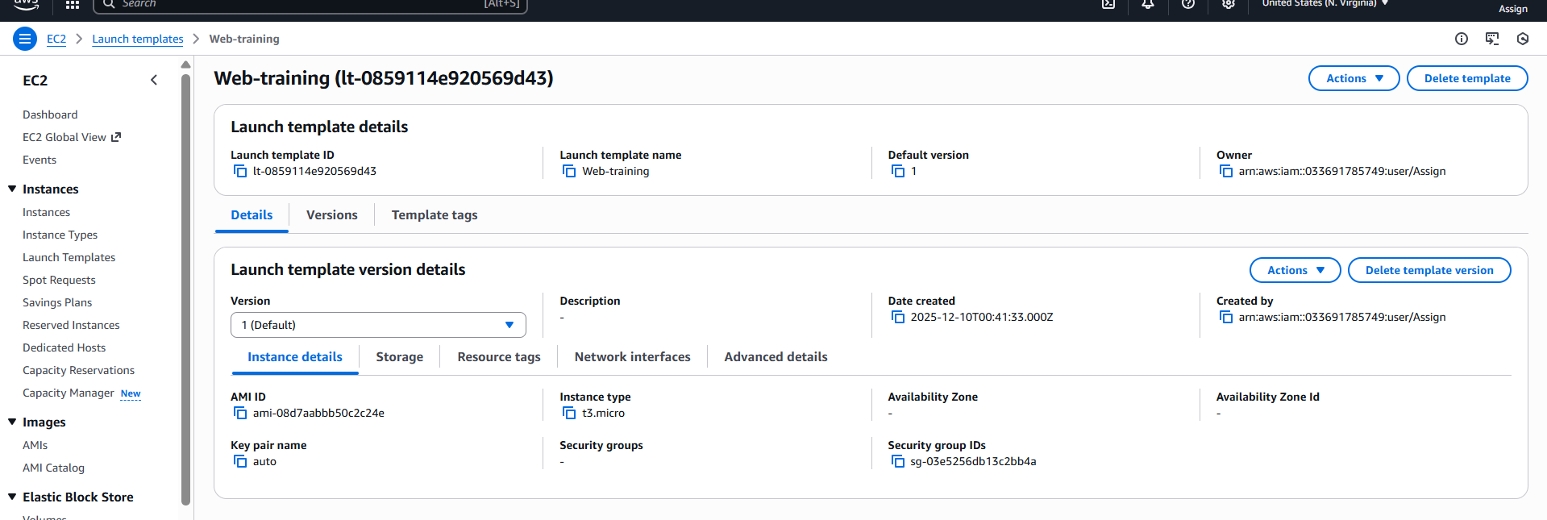

- Create Auto Scaling Group
- Go to EC2 → Auto Scaling Groups
- Click "Create Auto Scaling group"
- Select your launch template
Auto Scaling group name: webtrain
Launch template: web-server-template
VPC: Default VPC
Subnets: Select 2+ subnets in different AZs
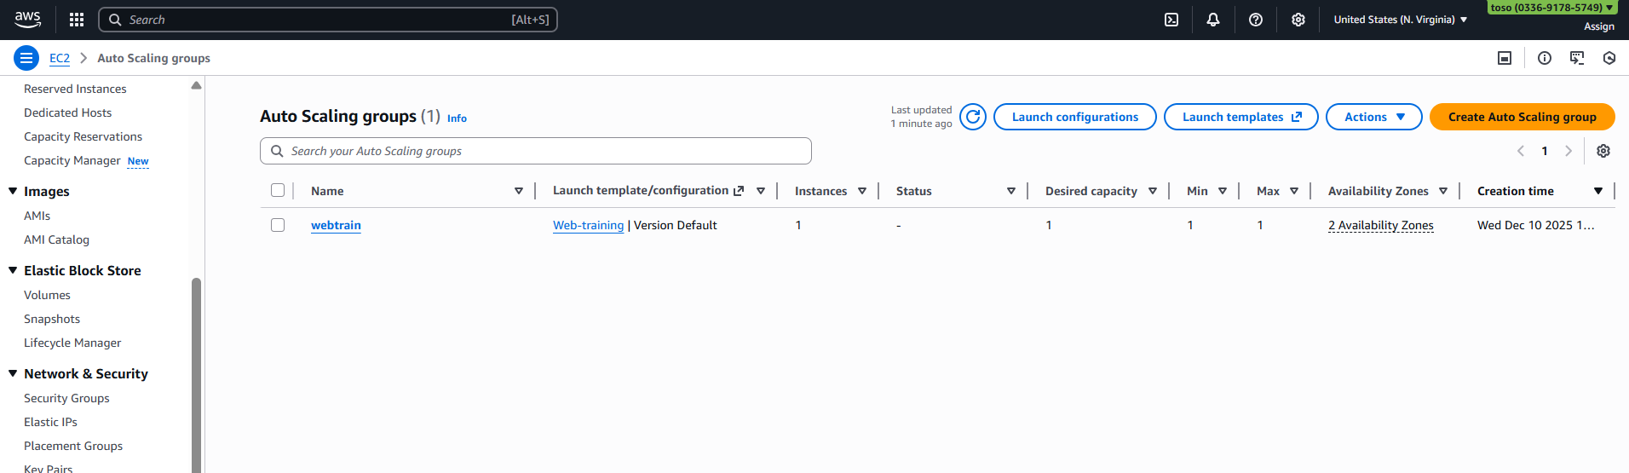

- Create Application Load Balancer
- Go to EC2 → Load Balancers
- Click "Create Load Balancer"
- Choose "Application Load Balancer"
Name: webtrain
Scheme: Internet-facing
IP address type: IPv4
VPC: Default VPC
Mappings: Select 2+ AZs with public subnets

Target Group Configuration

- Target type: Instances
- Protocol: HTTP
- Port: 80
- Health check path: /
- Health check interval: 30 seconds
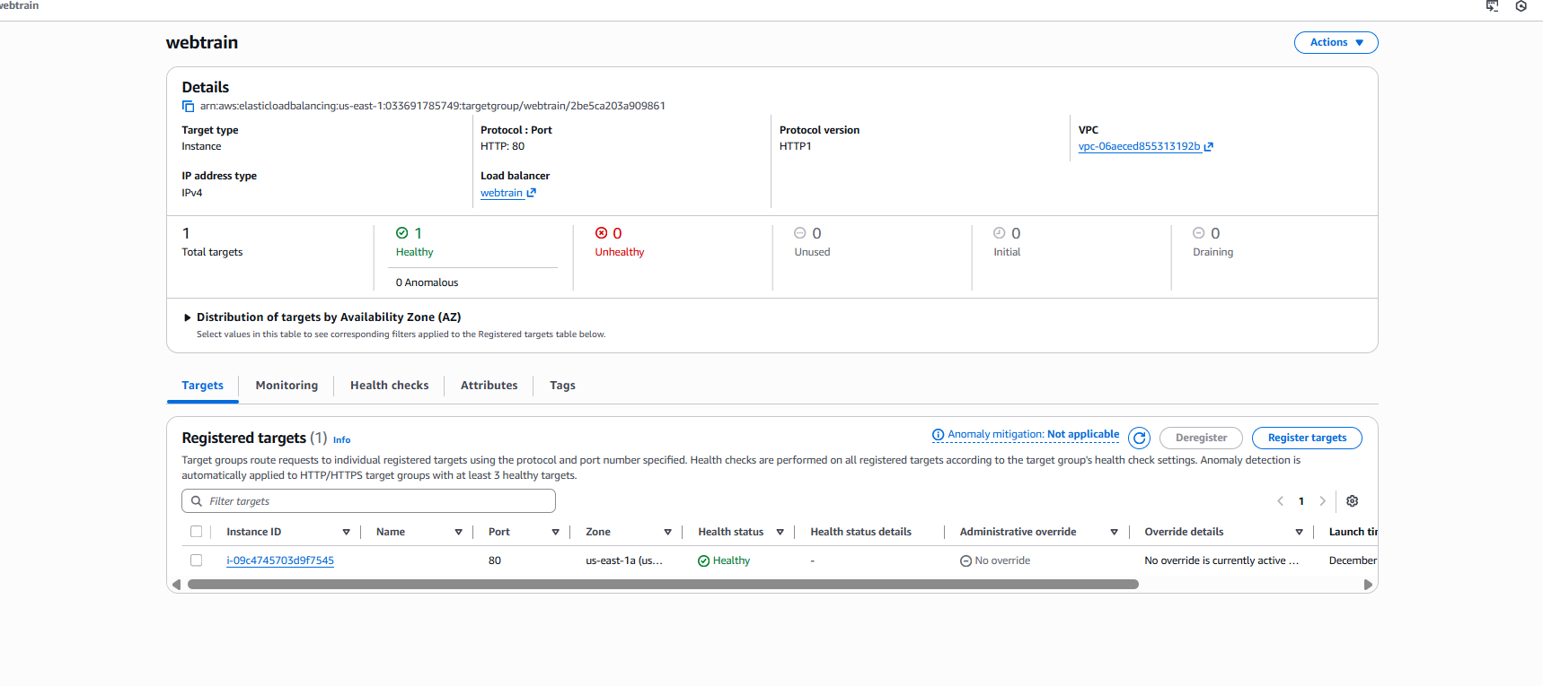
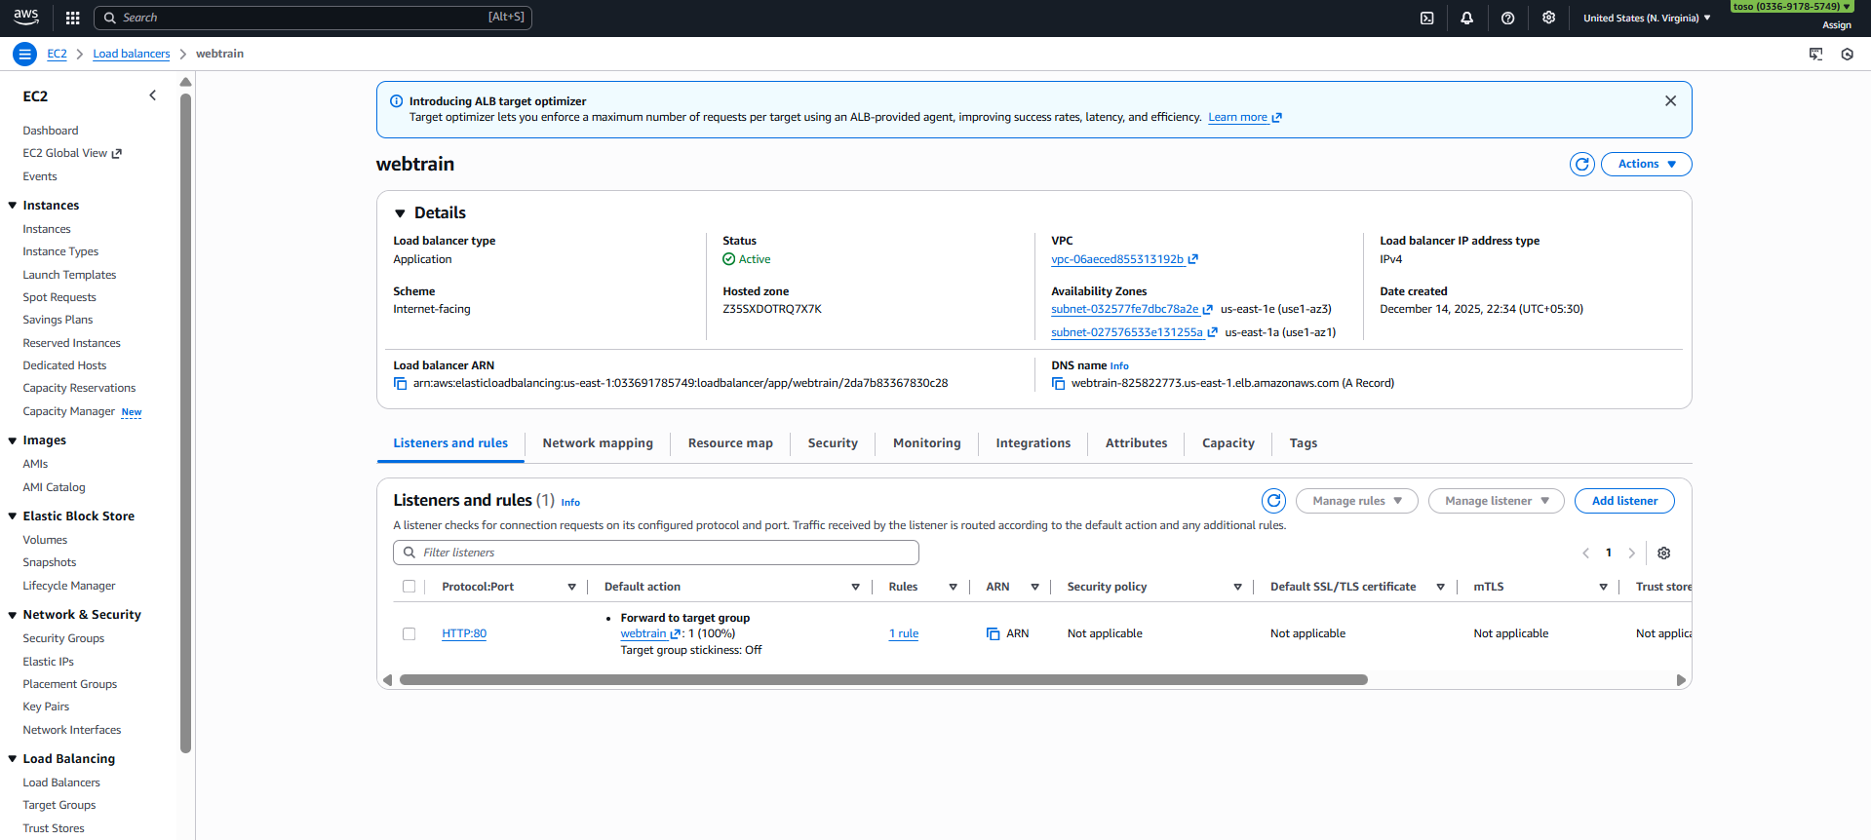

- Attach Load Balancer to Auto Scaling Group
- Go back to Auto Scaling Groups
- Select your ASG: web-server-asg
- Go to Details tab
- Click "Edit" in Load balancing section
Load balancing: Enable
Target groups: Select your target group
Health check type: ELB
Health check grace period: 300 seconds
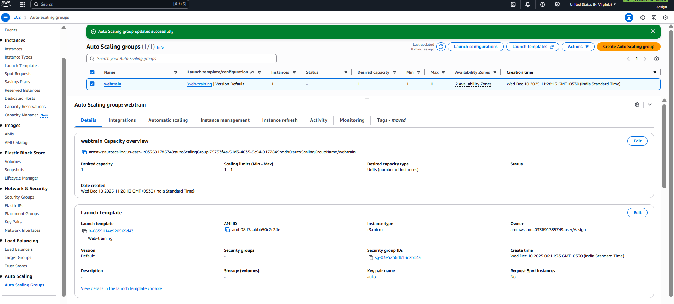
- Configure Dynamic Scaling Policies
- n ASG, go to Automatic scaling tab
- Click "Create dynamic scaling policy"
Policy type: Target tracking scaling
Metric type: Average CPU Utilization
Target value: 70%
Instance warmup: 300 seconds
